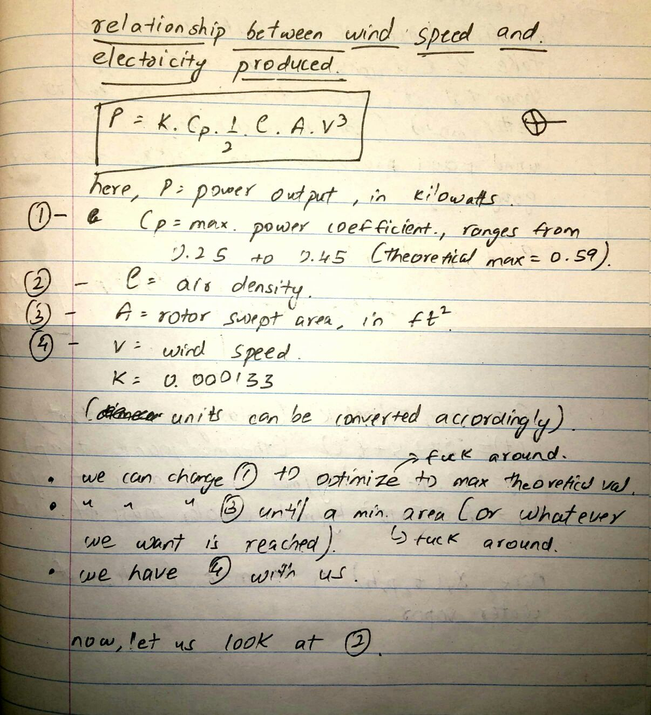

( let us figure out how air density is calculated )

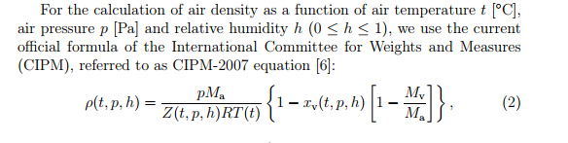

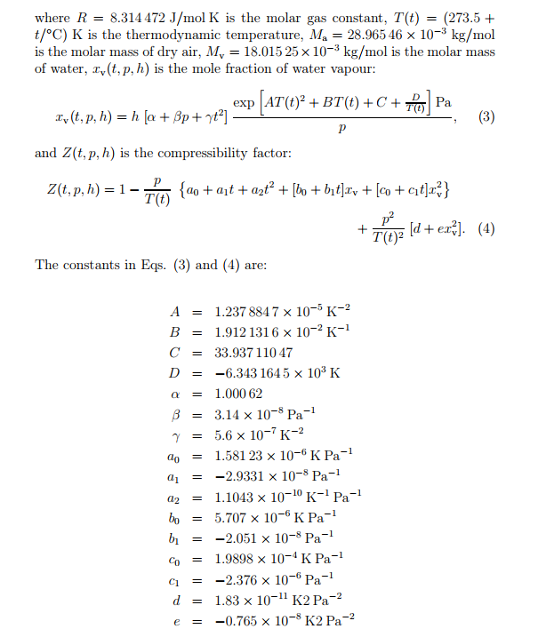

We have the values of humidity with us for each state ( two columns , max and min )

We do not have the air pressure with us , but we do have max and min elevation values.

Air pressure can be calculated by :

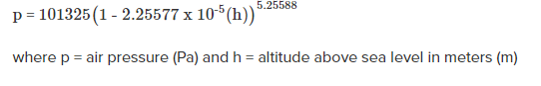

**Note : Keep in mind the values we have in the columns are in feet . This formula is for meters . Keep that in mind !**

**Relationship between solar and amount of electricity produced**



Solar array area : basically how big your panel is . This can be varied .

Solar radiation for the month is directly proportional to solar irradiance , therefore we can use that .   
Conversion efficiency – varies from 14 to 24 % ( can be changed according to what we need ) .